

**COMPUTER ENGINEERING**

**CG ODD SEM 2021-22/EXPERIMENT 4 NAME:- GAURAV AMARNANI (D7A, 67)**

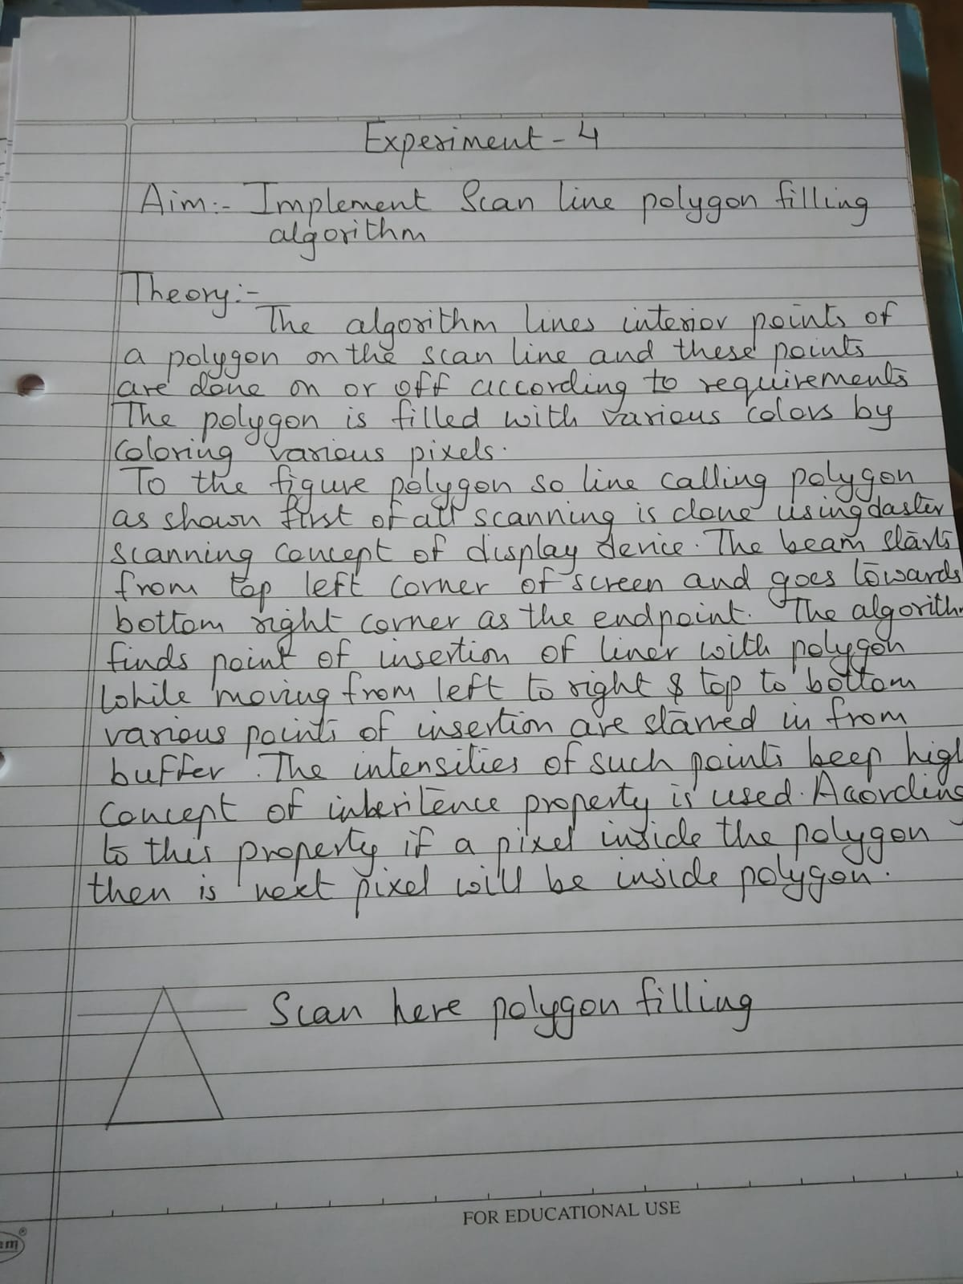

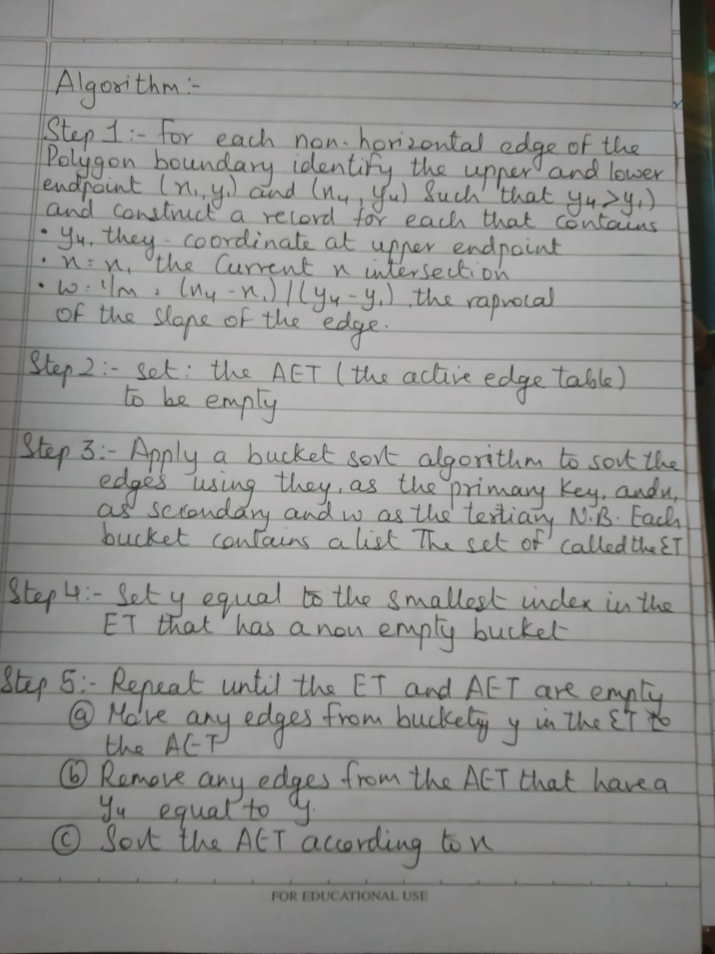



Program-

#include<stdio.h>

#include<conio.h>

#include<graphics.h>

void main() {

int n,i,j,k,gd,gm,dy,dx;

int x,y,temp;

int a[20][2],xi[20];

float slope[20];

clrscr();

printf("\n\n\tEnter the no. of edges of polygon : ");

scanf("%d",&n);

printf("\n\n\tEnter the cordinates of polygon :\n\n\n ");

for(i=0;i<n;i++) {

printf("\tX%d Y%d : ",i,i);

scanf("%d %d",&a[i][0],&a[i][1]);

}

a[n][0]=a[0][0];

a[n][1]=a[0][1];

detectgraph(&gd,&gm);

initgraph(&gd,&gm,"C:\\TurboC3\\BGI");

for(i=0;i<n;i++) {

line(a[i][0],a[i][1],a[i+1][0],a[i+1][1]);

}

getch();

for(i=0;i<n;i++) {

dy=a[i+1][1]-a[i][1];

dx=a[i+1][0]-a[i][0];

if(dy==0) slope[i]=1.0;

if(dx==0) slope[i]=0.0;

if((dy!=0)&&(dx!=0)) {

slope[i]=(float) dx/dy;

}

}

for(y=0;y< 480;y++) {

k=0;

for(i=0;i<n;i++) {

if( ((a[i][1]<=y)&&(a[i+1][1]>y))|| ((a[i][1]>y)&&(a[i+1][1]<=y))) {

xi[k]=(int)(a[i][0]+slope[i]*(y-a[i][1]));

k++;

}

}

for(j=0;j<k-1;j++) {

for(i=0;i<k-1;i++) {

if(xi[i]>xi[i+1]) {

temp=xi[i]; xi[i]=xi[i+1]; xi[i+1]=temp;

}

}

setcolor(3);

for(i=0;i<k;i+=2) {

line(xi[i],y,xi[i+1]+1,y);

getch();

}

}

}

Output:

